# Advanced Exercises

All Test Case will stay in assignment/exercisenumber/?.jpg

1. Test Case

|  |  |  |  |
| --- | --- | --- | --- |
| m | n | N! | result |
| 123 | -1 |  | Can not be integer |
| 7 | 12 | 4.790016 * 10^8 | Is Integer |
| 5 | 300 |  | Can not larger than 231 |
| abc | 25 |  |  |
| 29 | 66 | 5.443449390774431 * 10^92 | Not integer |

1. Test Case

F(X) ~ F(Y)

|  |  |  |
| --- | --- | --- |
| X | Y | Result |
| 1 | 12 | 1.0,1.0,2.0,3.0,5.0,8.0,13.0,21.0,34.0,55.0,89.0,144.0 |
| 22 | 44 | 17711.0,28657.0,46368.0,75025……….. |
| --1 | 99 | Wrong input, x and y should be positive and x > y |

1. Test Case

|  |  |
| --- | --- |
| size | Result |
| -1 | can not be negative or zero |
| 100 | 2.jpg |
| 999 | 3.jpg |

Random size all is between 1~1000 include length radius x and y point

1. Test Case

|  |  |
| --- | --- |
| Command | Result |
| Add to Tail:Test | Circular list [ Test -> Test ] |
| Add to Tail:LinkedLIst | Circular list [ Test -> LinkedLIst -> Test ] |
| Add to Tail:is | Circular list [ Test -> LinkedLIst -> is -> Test ] |
| Add to Tail:Circular | Circular list [ Test -> LinkedLIst -> is -> Circular -> Test ] |
| Add to Tail:or | Circular list [ Test -> LinkedLIst -> is -> Circular -> or -> Test ] |
| Add to Tail:not | Circular list [ Test -> LinkedLIst -> is -> Circular -> or -> not -> Test ] |
| Add to Head:HI | Circular list [ HI -> Test -> LinkedLIst -> is -> Circular -> or -> not -> HI ] |
| Remove index 2: | Circular list [ HI -> LinkedLIst -> is -> Circular -> or -> not -> HI ] |
| Remove From Head : | Circular list [ LinkedLIst -> is -> Circular -> or -> not -> LinkedLIst ] |

1. Test Case

|  |  |
| --- | --- |
| COmmand | Result |
| Initize arrayqueue size =5 | /5/1.jpg |
| Enqueue data sdad | /5/1.jpg |
| Enqueue data 123 | /5/1.jpg |
| Enqueue data 556 | /5/1.jpg |
| Enqueue data 899 | /5/1.jpg |
| Enqueue data asdvq | /5/1.jpg |
| Enqueue data 123 | Queue is full dequeue all |
|  |  |
|  |  |

6 Test Case

Pdf test case

0 2 2

0 6 1

1 7 5

0 8 2

1 10 7

Result

(a) The number of bus passed is:2

(b) Average number of people got on a bus is:2.5

(c) Average number of vacant seats for bus levaving:3.5

(d) People still waiting is :0

5 people waited for 15 minutes, average waiting time = 3.0 minutes.

Own test case

0 2 2

0 3 2

0 4 5

1 5 5

0 6 9

0 7 10

1 9 10

(a) The number of bus passed is:2

(b) Average number of people got on a bus is:7.5

(c) Average number of vacant seats for bus levaving:0.0

(d) People still waiting is :13

28 people waited for (49 minutes and (d) still waiting * last input time is :117 Total mins is 166 ), average waiting time = 5 minutes.

7 Test Case

Abc.txt

Text include = Read a paragraph containing words from an input file.

Then create a doubly-linked list containing the distinct words read, where

the words of the same length are placed in the same list,

in alphabetical order.

String is : [ a alphabetical an are containing create distinct doubly-linked file from in input length list of order paragraph placed Read read same the Then where words ]

ReverseString is : [ words where Then the same read Read placed paragraph order of list length input in from file doubly-linked distinct create containing are an alphabetical a ]

8. Test Case

1. int array is : {1,2,3,4,5,6,7,8,9,10,123,115161617,737373737} , Input index = 115161617

Result

Time Middle Index: 6 Middle Result 7

Time Middle Index: 9 Middle Result 10

Time Middle Index: 11 Middle Result 115161617

1. int array is : {5,7,11,13,26,37,88,99,111} , Input index = 111

Result

Time Middle Index: 4 Middle Result 26

Time Middle Index: 6 Middle Result 88

Time Middle Index: 7 Middle Result 99

Time Middle Index: 8 Middle Result 111

1. own result
2. For Your Own Test
3. 1:Add integer to int array , 2:End
4. 1
5. Number?
6. 5
7. 1:Add integer to int array , 2:End
8. 1
9. Number?
10. 9
11. 1:Add integer to int array , 2:End
12. 1
13. Number?
14. 2
15. 1:Add integer to int array , 2:End
16. 1
17. Number?
18. 3
19. 1:Add integer to int array , 2:End
20. 1
21. Number?
22. 99
23. 1:Add integer to int array , 2:End
24. 1
25. Number?
26. 123131515
27. 1:Add integer to int array , 2:End
28. 1
29. Number?
30. 555555
31. 1:Add integer to int array , 2:End
32. 2
33. Program Exit
34. non sorted :[5 9 2 3 99 123131515 555555 ]
35. sorted :[2 3 5 9 99 555555 123131515 ]
36. Which number u want to search
37. 555555
38. 1 Time Middle Index: 3 Middle Result 9
39. 2 Time Middle Index: 5 Middle Result 555555

9. Test Case

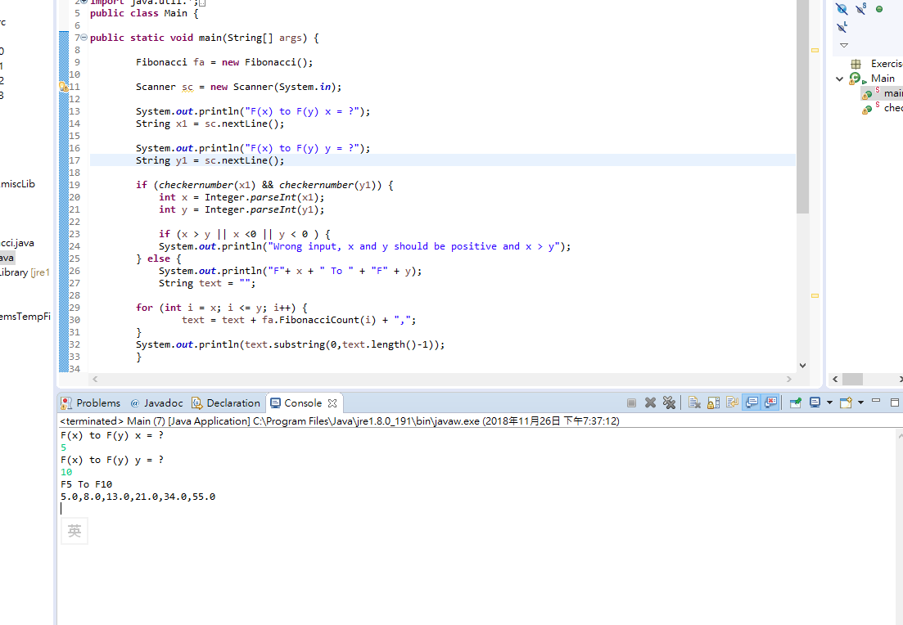

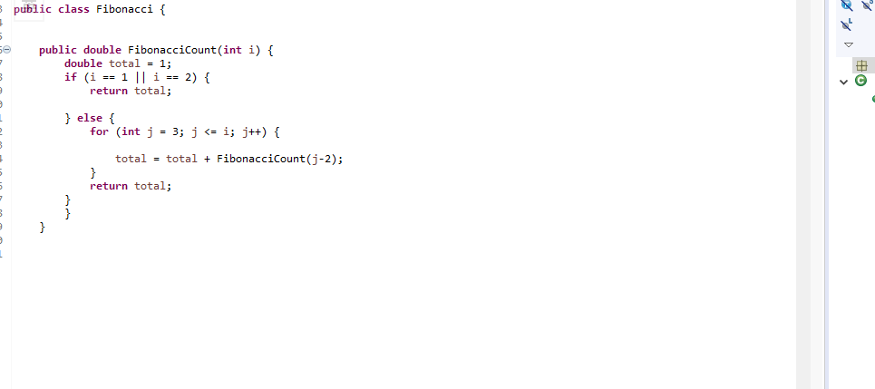

10. Test Case

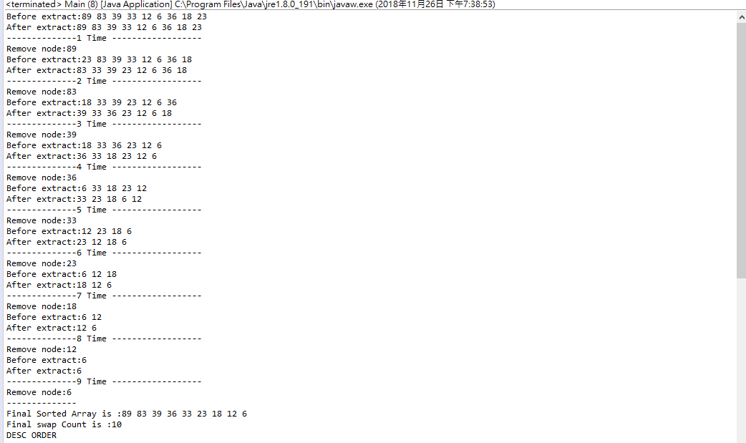

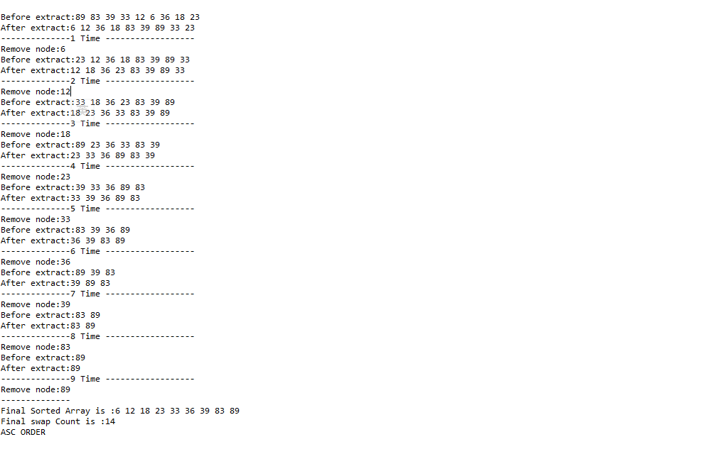

11TestCase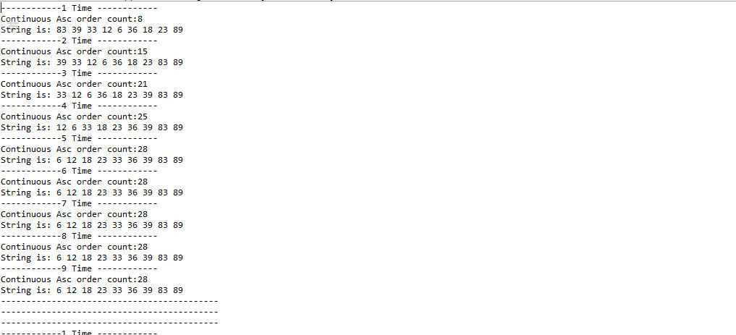

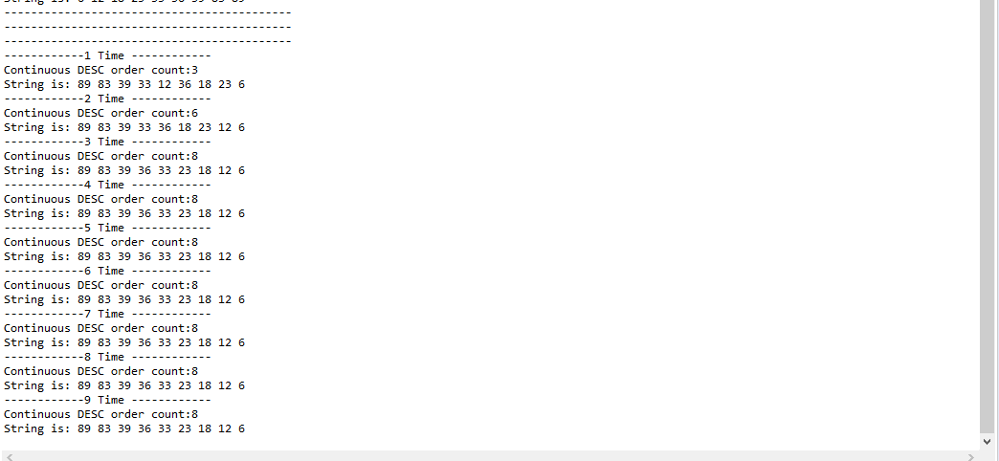

12. Test Case

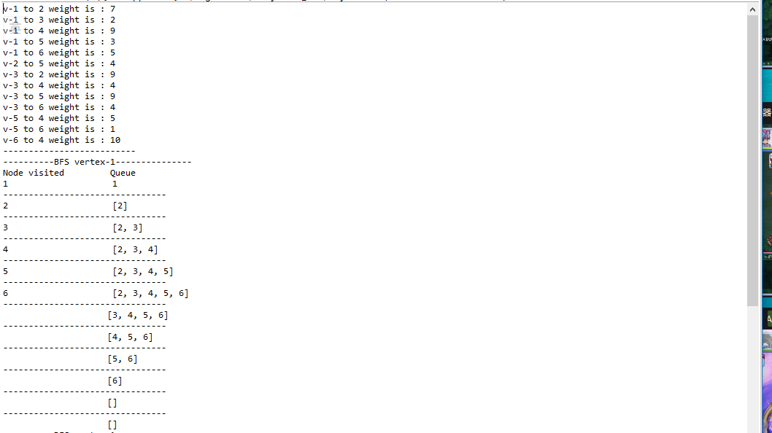

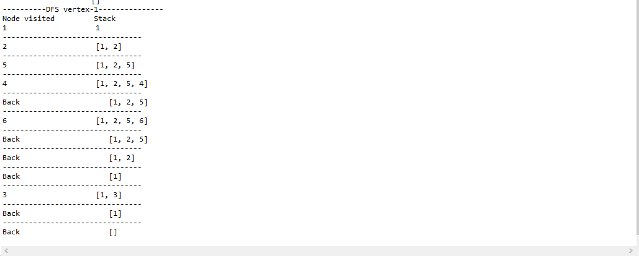

13 Test Case

